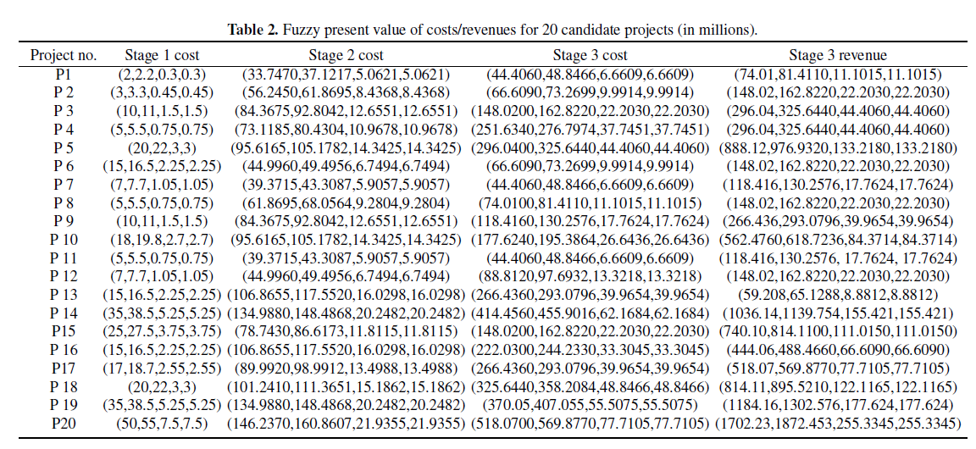

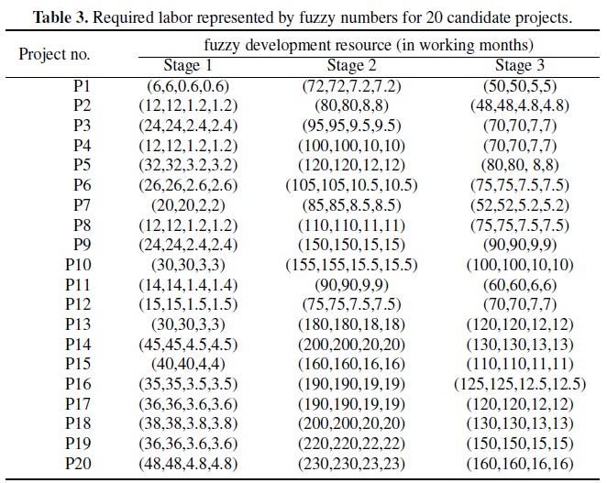

**Main function**

%%%%%%%%%%%%%%%%%%%%%%%%%%%%%%%%%%%%%%%%%%%%%%%

clear

load('数据.mat')

% 函数声明

global fun;global violate_fun;global D;

fun='obj_fun'; violate_fun='vio_g'; D=31;

global Q l L lowb upb MR Opt_sol w0 y1 y2 y3 c1 c2 sn

Q=data{1};Q{2}=Q{2}*1.1249;Q{3}=Q{3}*1.4802;

l=data{2};L=data{3};

MR=0.85;

limit=500;SPP=500;

sn=100;

MCN=2000;

Opt_sol=zeros(1,D);

Optimum=zeros(1,MCN);

lowb=zeros(1,D);

upb=[ones(1,D-11),ones(1,11)*7000];

w0=100;

y1=[2.1,3.15,10.5,5.25,21,15.75,7.35,5.25,10.5,18.9,5.25,7.35,15.75,36.75,26.25,15.75,17.85,21,36.75,52.5];

y2=[31.5,52.5,78.75,68.25,89.25,42,36.75,57.75,78.75,89.25,36.75,42,99.75,126,73.5,99.75,84,94.5,126,136.5];

y3=[31.5,47.25,105,178.5,210,47.25,31.5,52.5,84,126,31.5,63,189,294,105,157.5,189,231,262.5,367.5];

cmax=2;

cmin=0.5;

ispositive=1;

vio=zeros(MCN,sn/2);

max_yun=1;

Opt=zeros(max_yun,D+3);

for yun=1:max_yun

tic

failure=zeros(1,sn/2);

Col_fitness=zeros(1,sn/2);

Col_f=zeros(1,sn/2);

Col_violation=zeros(1,sn/2);

Colony=zeros(sn/2,D);

w=[w0,zeros(1,11)];

for i=1:sn/2

while 1

Colony(i,1)=rand;

for j=2:D-11

Colony(i,j)=4*Colony(i,j-1)*(1-Colony(i,j-1));

end

for j=1:D-11

if Colony(i,j)<=0.5

Colony(i,j)=0;

else

Colony(i,j)=1;

end

end

x=Colony(i,1:20);y=zeros(1,11);

y11=y1*x'/3;y21=y2*x'*1.1249/7;y31=y3*x'*1.4802;

c_cost(1:3)=y11;c_cost(4:10)=y21;c_cost(11)=y31;

for j=1:11

if w(j)>c_cost(j)

y(j)=0;

w(j+1)=(w(j)-c_cost(j))*1.025;

else

if j==1 || y(j-1)==0

y0=rand;

else

y0=4*y0*(1-y0);

end

y(j)=y0*upb(20+j);

end

end

Colony(i,D-11+1:D)=y;

[Col_fitness(i),Col_f(i),Col_violation(i),ispositive]=evaluation(Colony(i,:));

if ispositive==1

break;

else

disp('不满足非负');

end

end

end

[max_fit,n]=max(Col_fitness);

if max_fit>0

Opt_sol=Colony(n,:);

min_vio=0;

best_f=Col_f(n);

else

[min_vio,m]=min(Col_violation);max_fit=0;

Opt_sol=Colony(m,:);

best_f=Col_f(m);

end

Cycle=1;

while Cycle<=MCN

c1=(cmin-cmax)*Cycle/MCN+cmax;

c2=(cmax-cmin)*Cycle/MCN+cmin;

for i=1:sn/2

while 1

v=modify(Colony,i);

[v_fitness,v_f,v_violation,ispositive]=evaluation(v);

if ispositive==1

break;

else

disp('v不满足非负');

end

end

isupdate=selection_Deb(Col_violation(i),v_violation,Col_f(i),v_f);

if isupdate==0

failure(i)=failure(i)+1;

else

Colony(i,:)=v;

Col_fitness(i)=v_fitness;

Col_f(i)=v_f;

Col_violation(i)=v_violation;

failure(i)=0;

end

end

p=zeros(1,sn/2);

for i=1:sn/2

p(i)=calculate_pro(i,Col_fitness,Col_violation);

end

t=0;i=1;

while t<sn/2

if i==0

i=1;

end

if rand<p(i)

t=t+1;

while 1

v=modify(Colony,i);

[v_fitness,v_f,v_violation,ispositive]=evaluation(v);

if ispositive==1

break;

else

disp('v不满足非负');

end

end

isupdate=selection_Deb(Col_violation(i),v_violation,Col_f(i),v_f);

if isupdate==0

failure(i)=failure(i)+1;

else

Colony(i,:)=v;

Col_fitness(i)=v_fitness;

Col_f(i)=v_f;

Col_violation(i)=v_violation;

failure(i)=0;

end

end

i=i+1;

i=mod(i,sn/2+1);

end

if mod(Cycle,SPP)==0

for i=1:sn/2

if failure(i)>limit

while 1

Colony(i,1:D-11)=round(rand(1,D-11));

x=Colony(i,1:20);y=zeros(1,11);

y11=y1*x'/3;y21=y2*x'*1.1249/7;y31=y3*x'*1.4802;

c_cost(1:3)=y11;c_cost(4:10)=y21;c_cost(11)=y31;

for j=1:11

if w(j)>c_cost(j)

y(j)=0;

w(j+1)=(w(j)-c_cost(j))*1.025;

else

y(j)=rand*upb(20+j);

end

end

Colony(i,D-11+1:D)=y;

failure(i)=0;

[Col_fitness(i),Col_f(i),Col_violation(i),ispositive]=evaluation(Colony(i,:));

if ispositive==1

break;

else

disp('不满足非负');

end

end

end

end

end

vio(Cycle,:)=Col_violation;

[max_fit1,n]=max(Col_fitness);

if max_fit1>0

bestpop=Colony(n,:);

min_vio1=0;

best_ff=Col_f(n);

else

[min_vio1,m]=min(Col_violation);max_fit1=0;

bestpop=Colony(m,:);

best_ff=Col_f(m);

end

isupdate=selection_Deb(min_vio,min_vio1,best_f,best_ff);

if isupdate==1

Opt_sol=bestpop;

max_fit=max_fit1;min_vio=min_vio1;

end

if max_fit>0

spp=200;limit=200;

end

Optimum(Cycle)=max_fit;

Cycle=Cycle+1;

end

figure;

plot(Optimum,'b');

xlabel('Generation');

ylabel('fitness');

x=Opt_sol(1:20);y=Opt_sol(D-11+1:D);

y11=y1*x'/3;y21=y2*x'*1.1249/7;w=zeros(1,11);

w(1)=w0;

for i=2:4

w(i)=(w(i-1)+y(i-1)-y11)*1.025-y(i-1)*1.045;

end

for i=5:11

w(i)=(w(i-1)+y(i-1)-y21)*1.025-y(i-1)*1.045;

end

Opt_val=feval(fun,Opt_sol,w(11));

wealth=w(11)+4.0456*(52.5*x(1)+ 105*x(2)+ 210*x(3)+ 210*x(4)+ 630*x(5)+ 105*x(6)+ 84*x(7)+ 105*x(8)+ ...

189*x(9)+ 399*x(10)+ 84*x(11)+ 105*x(12)+ 42*x(13)+ 735*x(14)+ 525*x(15)+ 315*x(16)+ 367.5*x(17)+...

577.5*x(18)+ 840*x(19)+ 1207.5*x(20))- (31.5*x(1)+ 47.25*x(2)+ 105*x(3)+ 178.5*x(4)+ 210*x(5)+...

47.25*x(6)+ 31.5*x(7)+ 52.5*x(8)+ 84*x(9)+ 126*x(10)+ 31.5*x(11)+ 63*x(12)+ 189*x(13)+...

294*x(14)+ 105*x(15)+ 157.5*x(16)+ 189*x(17)+ 231*x(18)+ 262.5*x(19)+ 367.5*x(20))*1.4802;

disp('x的最优解=');disp(num2str(x));

disp('s的最优解=');disp(num2str(x));

disp('y的最优解=');disp(num2str(y));

disp('y的最优解的和=');disp(num2str(sum(y)));

disp('最优值=');disp(num2str(Opt_val));

disp('期末财富值=');disp(num2str(wealth));

yun

Opt(yun,:)=[Opt_sol,Opt_val,wealth,min_vio];

toc

sum(x)

end